**Q1. Find Second Largest Element from the Array?**

class A1{

public static void main(String args[]){

int arr[]={100,20,300,40,500};

int max=arr[0];

for(int i=0;i<arr.length;i++){

if(arr[i]>max){

max=arr[i];

}

}

System.out.println("First MAX ELEMENT : "+max);

int max1=arr[0];

for(int i=0;i<arr.length;i++){

if(arr[i]>max1&&arr[i]<max){

max1=arr[i];

}

}

System.out.println("Second MAX ELEMENT : "+max1);

}

}

Q2. Explain Multidimensional Array / 2D Array in java programming?

Ans:

A Multidimensional Array is an Array of Arrays

A Multidimensional Array is useful when we want to store data in Tabular form or Matrix form

Syntax:

Data type[][]=new data type[ROW SIZE][COLUMN SIZE];

Example:

int A[][]=new int[3][3];

A

|  |  |  |  |
| --- | --- | --- | --- |
|  | COLUMN 0 | COLUMN 1 | COLUMN 2 |
| ROW 0 | 00(10) | 01(20) | 02(30) |
| ROW 1 | 10(40) | 11(50) | 12(60) |
| ROW 2 | 20(70) | 21(80) | 22(90) |

How to initialize 2D Array

ArrayName[ROW INDEX][COLUMN INDEX]=value;

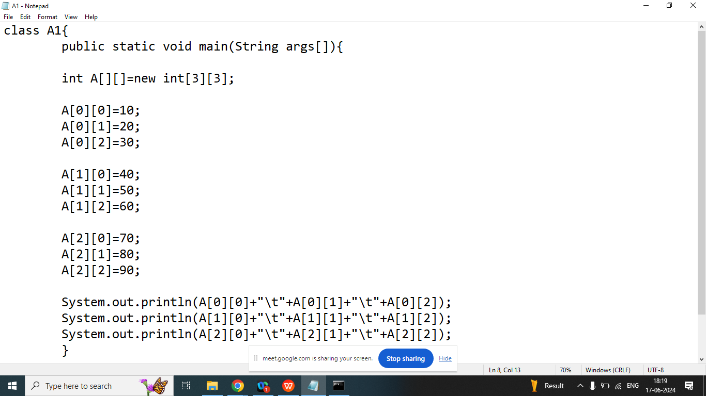

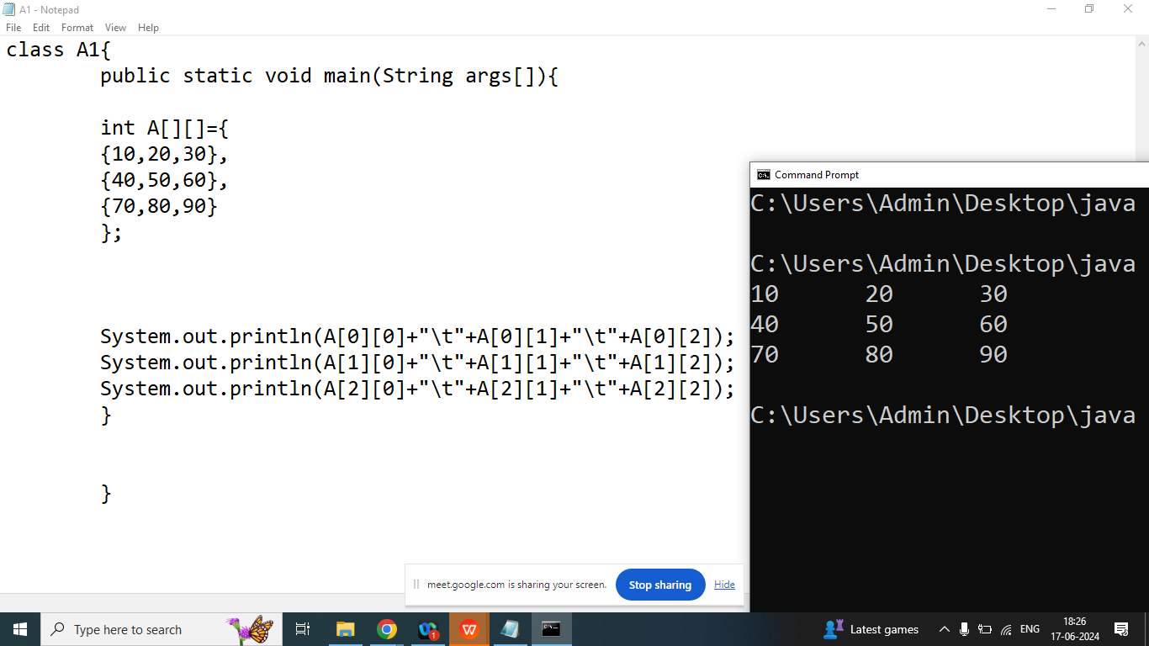

import java.util.Scanner;

class A1{

public static void main(String args[]){

int A[][]=new int[3][3];

Scanner obj=new Scanner(System.in);

System.out.println("Enter Element Index of 00 : ");

A[0][0]=obj.nextInt();

System.out.println("Enter Element Index of 01 : ");

A[0][1]=obj.nextInt();

System.out.println("Enter Element Index of 02 : ");

A[0][2]=obj.nextInt();

System.out.println("Enter Element Index of 10 : ");

A[1][0]=obj.nextInt();

System.out.println("Enter Element Index of 11 : ");

A[1][1]=obj.nextInt();

System.out.println("Enter Element Index of 12 : ");

A[1][2]=obj.nextInt();

System.out.println("Enter Element Index of 20 : ");

A[2][0]=obj.nextInt();

System.out.println("Enter Element Index of 21 : ");

A[2][1]=obj.nextInt();

System.out.println("Enter Element Index of 22 : ");

A[2][2]=obj.nextInt();

System.out.println(A[0][0]+"\t"+A[0][1]+"\t"+A[0][2]);

System.out.println(A[1][0]+"\t"+A[1][1]+"\t"+A[1][2]);

System.out.println(A[2][0]+"\t"+A[2][1]+"\t"+A[2][2]);

}

}